|  |  |
| --- | --- |
|  | February 2020 |

Market Update

|  |  |  |
| --- | --- | --- |
| For information | By Andrew Gall |  |

* Weak growth, despite recent survey data suggesting a post-Election pick up in confidence
* Mortgage market flat in 2019 as competition remains intense
* Rising real pay and precautionary saving lead to strong deposit growth

SURVEYS indicating pick up in confidence but outlook still subdued

1. The UK economy is not expected to have grown much, if at all, in the final quarter of 2019 due to the effects of Brexit-related uncertainty as well as slowing global growth. Now, both of these factors have reduced: global growth has stabilised and the decisive General Election result has removed some of the question marks over the direction of policy, and the UK has now formally left the EU. Survey indicators suggest economic growth will pick up in the first quarter of 2020. However, growth is still expected to remain relatively weak in the year ahead, with an average forecast of 1.1%. Uncertainty remains about the shape of the UK’s future relationship with the EU, weighing on business investment decisions, and Coronavirus will have an impact on global growth. If the recent survey indicators do not translate into increased economic activity, the Monetary Policy Committee (MPC) may cut the Bank Rate to support demand in the economy. However, the Budget on 11 March is expected to outline increased Government spending, supporting growth.
2. However, looking further ahead, the MPC’s recent forecasts assume that the persistent weakness of productivity growth in the UK (compounded by Brexit’s effect on business investment) means that the UK economy cannot grow very rapidly without generating inflationary pressure. The MPC forecasts that the supply capacity of the economy will grow an average of 1.1% over the next three years, compared to 2.9% a year in the decade prior to 2007, and 1.6% from 2010-2018. As a result, even historically weak rates of economic growth could, in time, result in the Bank having to raise rates to bring inflation down to its 2% target. The MPC has said that if the economy evolves in line with its forecasts over the next three years some modest tightening may be needed.
3. The labour market remains tight with a record high employment rate of 76.3% in September-November 2019, though the rise in the employment rate has levelled off in recent periods. The unemployment rate was at a forty year low, at 3.8%. Employees’ regular pay grew by 3.4% in the year to September to November 2019, though this was lower than the 3.9% seen in early summer last year.
4. Consumer prices grew by 1.3% over the year to December, based on the CPI measure. Inflation continues to be affected by regulatory price caps in the energy market, but also weak underlying inflation. The MPC is investigating the discrepancy between average earnings, which have grown relatively strongly in recent months, and why this hasn’t translated into higher general price inflation. Part of the story is that consumer-facing companies have reduced their profit margins. This may have been a one-off adjustment; the start of an ongoing structural change reflecting technological changes; or that the labour market was not as tight as had been estimated. Which of these applies has differing implications for future monetary policy in order to hit the 2% inflation target.

Mortgage markeT flat in 2019 as competition remains intense

1. Gross mortgage lending in December was £22.3 billion, 7% higher than the same month a year earlier. Some buyers may have held off completing transactions in prior weeks until the election result was clear. The number of mortgages approved in December were up 9% on December in the prior year.
2. Over the course of the 2019, gross mortgage lending was £268 billion, little changed from £269 billion in 2018. There were almost 1.55 million mortgages approved in the UK last year, up just 1% from 2018. 51% of these loans were for house purchase, 38% were remortgages, and 11% further and other advances. These proportions are unchanged from 2018.
3. As in the wider economy, RICS’ [survey](https://www.rics.org/globalassets/rics-website/media/knowledge/research/market-surveys/december-2019-rics-uk-residential-market-survey.pdf) indicated an improvement in sentiment after the General Election result. Surveyors’ sales expectations rose sharply, while estimates of new buyer enquiries and instructions to sell turned positive. However, the low stock of properties on the market means that surveyors anticipate house price growth to accelerate. Nationwide’s index showed an increase in house price inflation in January, to 1.9% on an annual basis, from 1.4% in December. Results from the BSA’s Property Tracker survey have previously suggested that even if Brexit-related uncertainty were removed, the constraints on borrower affordability would continue to limit the extent of bounce-back in activity.
4. [Analysis](https://www.resolutionfoundation.org/publications/housing-outlook-q1-2020/) from the Resolution Foundation looks at the differential performance of regional house prices, with prices having grown fastest since 2016 where they were lowest to begin with, as many regions closed the gap slightly to London and the South East.
5. 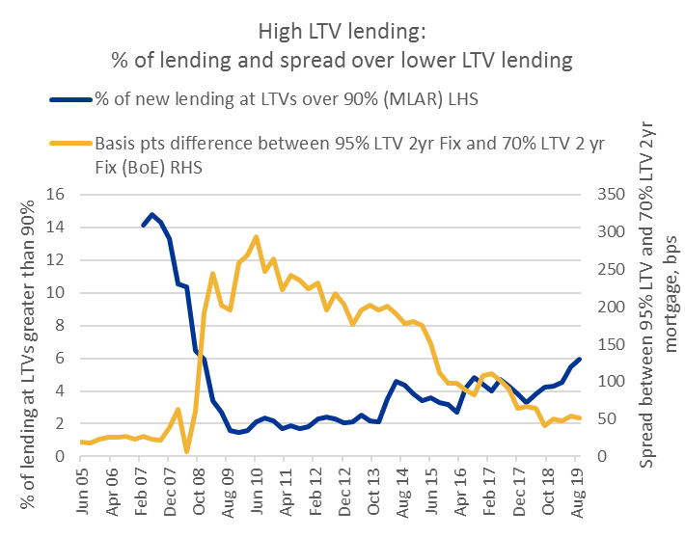By Q3 2019 the proportion of lending at LTVs greater than 90% had increased to 6% of all new lending, its highest level since the crisis (see chart). The interest rate spread between high and low LTV lending has narrowed from its post crisis highs. However, even with the intensity of competition in the mortgage market, this spread remained steady in 2019, at around 50 basis points. This is roughly double the spread prior to the credit crunch.
6. In its review of its mortgage market tools in December, the FPC took solace that despite the intense competition in the mortgage market, the fact that its tools had not had more bite was evidence that underwriting standards had generally been maintained.
7. Average mortgage interest rates published by the Bank show that floating rates rose slightly to 1.95% in December from 1.93% in November. Fixed rates were flat, at 1.87%.

**Rising real pay and precautionary saving lead to strong deposit growth**

1. Households’ savings deposits grew by £64 billion in 2019, compared to £47 billion in 2018, the largest annual increase for three years. This is due to earnings growing faster than price inflation, together with households increasing cash saving as a precaution against the economic uncertainty and turbulence in the stock market at certain points in the year.
2. Investments into other asset classes were quite volatile through 2019, again reflecting the uncertain environment and geo-political tensions. Up to November, there were £11 billion of net sales of unit funds, according to the Investment Association, versus £8 billion in the whole of 2018. Equity and property funds had net withdrawals in 2019, with fixed income funds the asset class with the highest net sales.
3. Average savings rates published by the Bank shows were broadly flat at 0.48% in December, from 0.47% in November. Average rates on time (fixed, notice and ISA) accounts fell to 0.97% in December from 1.12% in November. Falls in the month were mainly in ISAs and 2 year fixed rate bonds.
4. From September this year, Child Trust Funds (CTFs) will start to mature as the first account-holders turn 18. All children born between 2002 and 2011 were given vouchers by the Government of at least £250 with which to open an account.
5. 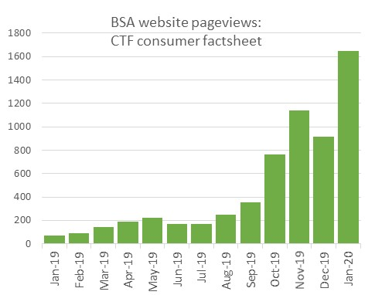Over 6 million CTFs were opened. Of these, 5 million were invested in stocks and shares, within which almost 2 million were opened as default accounts when the vouchers expired. Just over 1 million Cash CTFs were opened and the building society sector accounted for about two thirds of these. In 2018, CTF balances at BSA members totalled almost £1 billion, with an average balance of around £1,400.
6. We have recently seen a significant increase in page views on the BSA website’s CTF consumer factsheet (see chart), which has become one of the most visited pages on our site, possibly as current 17 year olds look ahead to their birthday windfalls.

DECEMBER 2019









Average economic forecasts

Average independent forecasts for 2019 –2020 compiled by HM Treasury in January 2020 and medium term forecasts for 2021- 2023 in December 2019. For full details, see the Treasury website [here](https://www.gov.uk/government/collections/data-forecasts).



4 February 2020